Vending Machine Project

This document will contain information about the project made by

Eneojo Solomon Unwuchola

***Background***

I made this project because I found myself using the vending machine quite a bit especially to grab a snack/drink on late night study Sessions. I decided to make a project to model how it works but not only for the user but for the person that fills the vending machine.

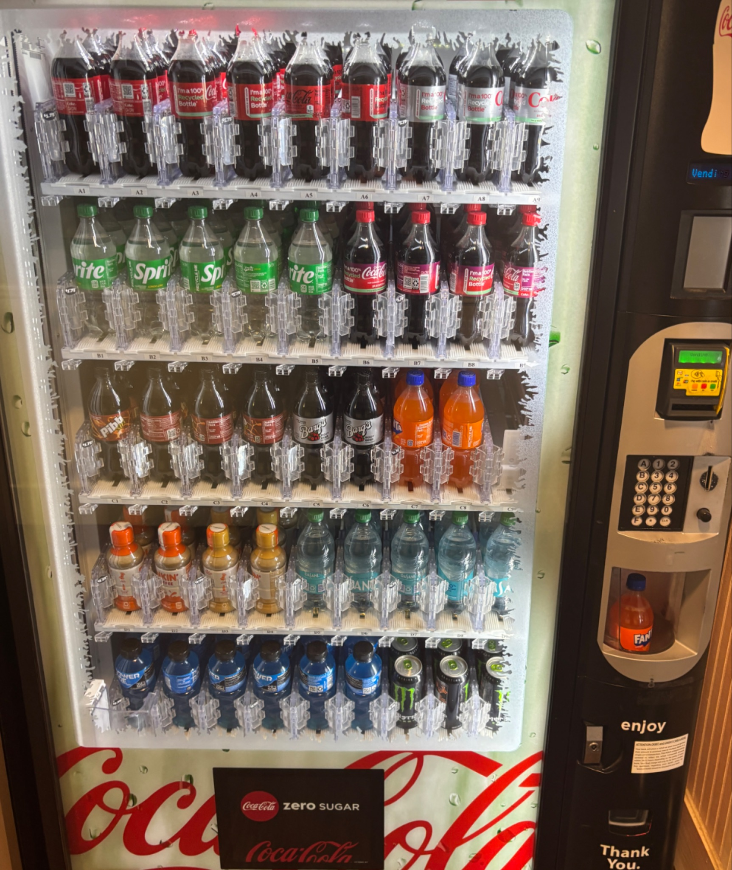

***Project Information***

My program is a text-based vending machine program that allows users to buy drinks, restock drink inventory, and manage drink/product information through a terminal interface. It uses a file handling system to save and load inventory data, ensuring that changes can be accessed by other files.

Features

* Drink Selection – Users can choose from available drinks and purchase them.
* Restocking System – Admins can add more stock to existing items.
* Editing Product Details – The program allows modification of drink names, prices, and stock levels.
* Memory handling – All inventory data is saved and loaded using a file, preventing data loss.

The goal of this project is to simulate how a vending machine operates in real life, focusing on functionality rather than visuals.

***Visualization of how it works***

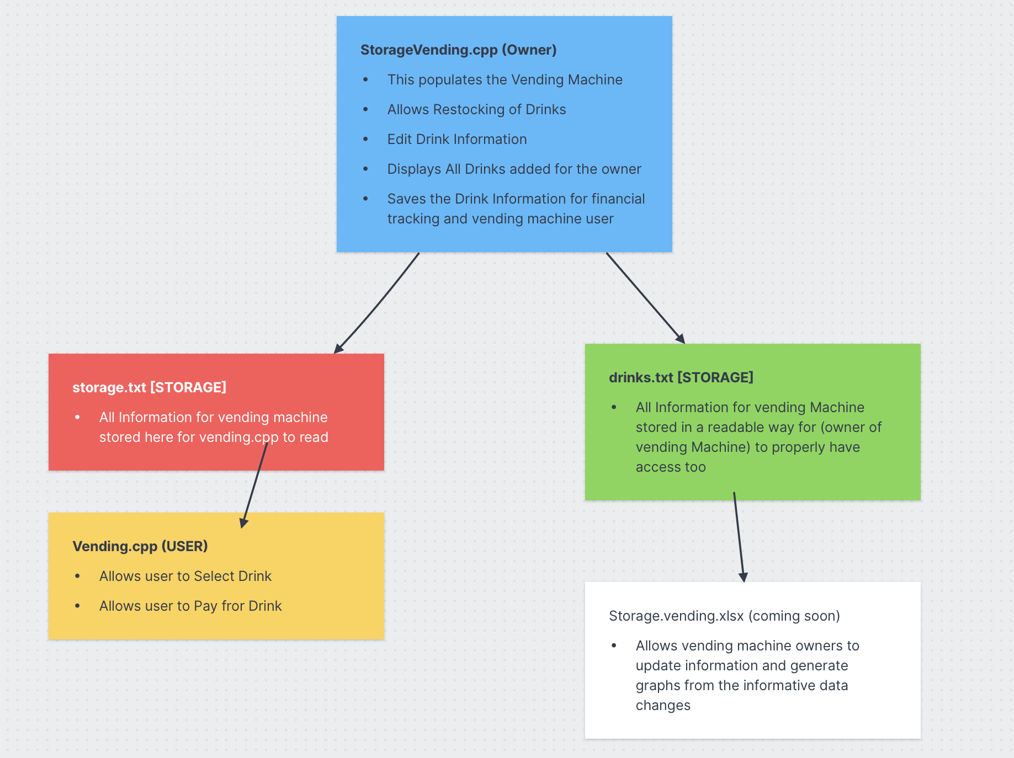

**How to set up & use**

1. Download and store each files into the same folder (prevents linking errors)
2. Open project in an IDE e.g VScode,Xcode,cLion
3. Start by running the storageVending.cpp file and populating the vending Machine
4. After your done with populating Vending Machine and editing Product Information
5. Save Information by selecting 6 on Information
6. Afterwards Run vending.cpp and select drink from options
7. Access drinks.txt to see All drink information after step 5 has been completed

***Project should like:***   
  
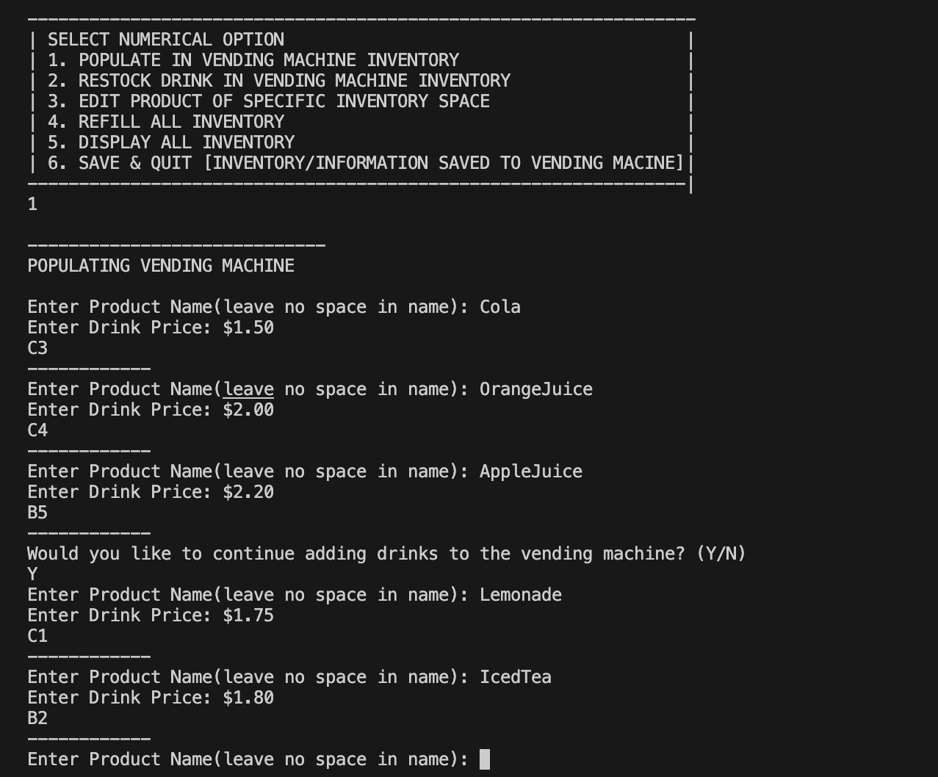

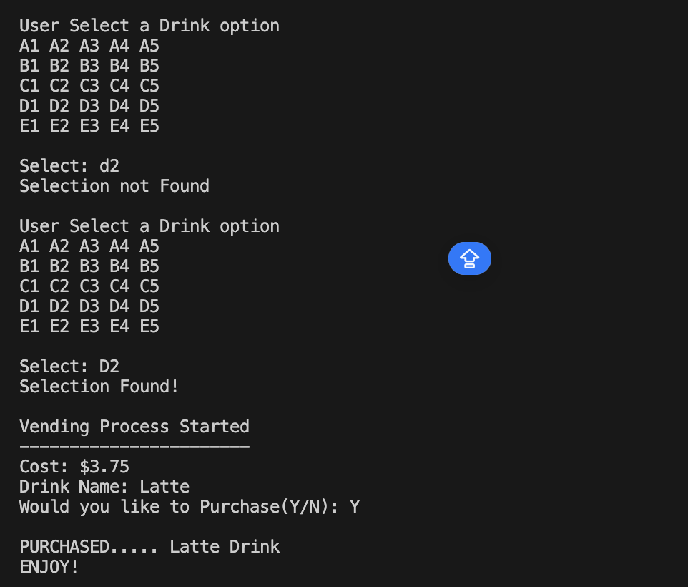

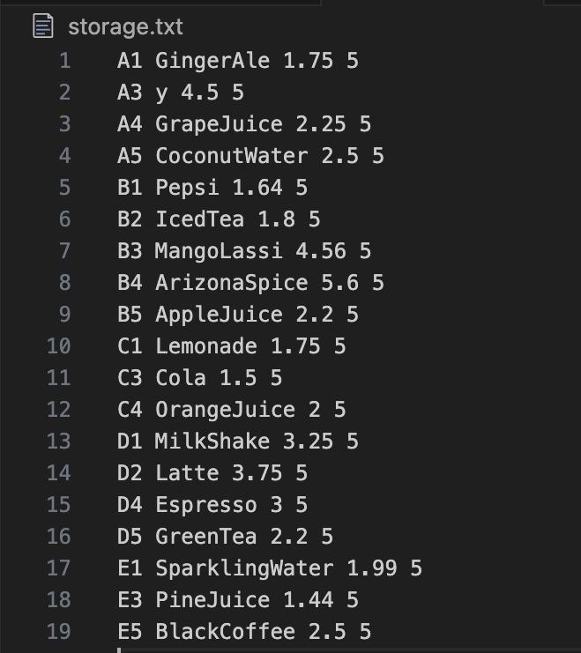

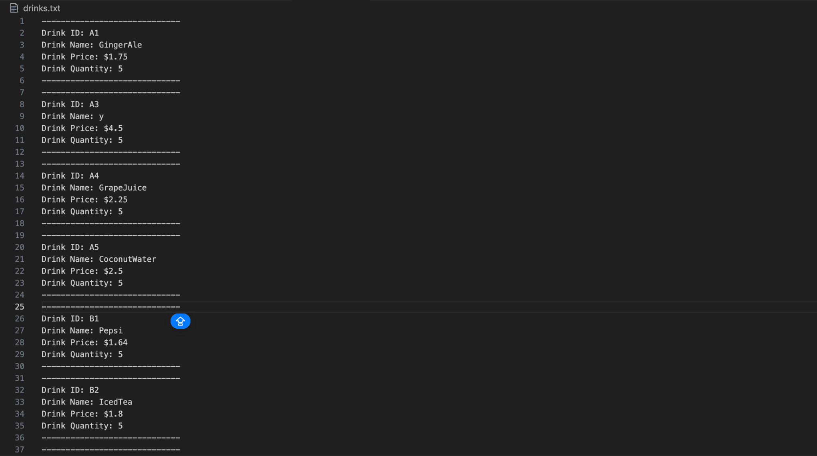

***Possible Errors to look out for***

* When adding product Name leave no space while populating ( this affects memory Handline)

**Conclusion**

I enjoyed making this project and it was fun trying to make something that I use frequently. It gave me a better understanding of how vending machine systems work. If you encounter any errors please let me know in the discussion section